Guide-book for fans

European Men Basketball
Championship
Final round

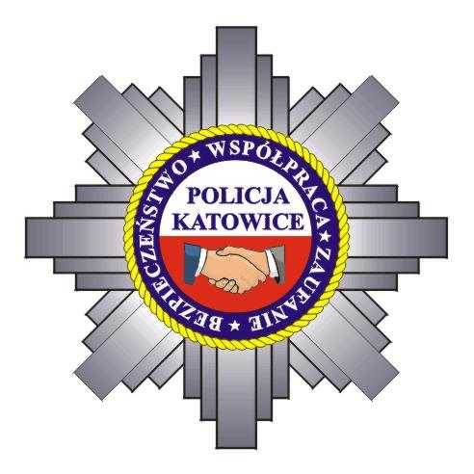

Fair Play = Safety

Katowice, 17–20.09.2009

Life-saving City Center  Katowice, 9 Młyńska St. | 112
The Police Station  Katowice , 19 Lompy St. | 997  ( 032) 200-25-55
Ambulance Service | 999
Fire Brigade | 998
Municipal Police | 986
Safety telephone for foreign tourists temporary stay at the Republic of Poland territory | 0 800 200 300  0 608 599 999
Embassies and consular offices | www.msz.gov.pl www.mswia.gov.pl

More information:

www.fibaeurope.com
www.eurobasket2009.org
www.pzkosz.pl
www.katowice.eu
www.katowice.slaska.policja.gov.pl
www.kzkgop.pl

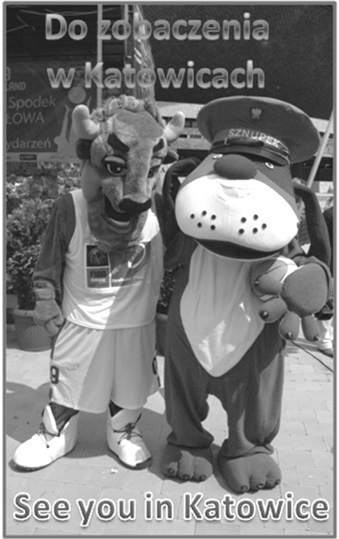
Katowice
The city of remarkable events! If you do not believe it just come and see it with your own eyes. Visit the city not only to find out that it has completely changed its industrial image but also to participate in the numerous cultural or sporting events. Let’s take a look at the most important and prestigious events that are held, inter alia, in the SPODEK Arena which has been recently thoroughly renovated. September 2009 will be a month full of great sport events because the Spodek Arena will host the final round of EuroBasket 2009 as well as group matches and semi- finals of the Women’s European Volleyball Championship. In October there will take place the 29th edition of the “Rawa Blues Festival” which is considered to be the world’s most important blues festival. As there will be organised the traditional Mayday Festival in the Spodek fervent fans of electronic music will find something interesting for themselves too. There will be held also the Nature One Poland electronic music concert with the participation of the best DJs from all over the world on the local airport “Muchowiec” as well as the New Music Festival (Polish: Festiwal Nowa Muzyka) on the area of former coal-mine “Katowice”. Apart from the sport and cultural entertainments visitors can relax in one of the numerous pubs, clubs and cosy cafés. Furthermore, restaurants in Katowice serve food from different corners of the world, so everyone will find something good for himself/herself. But it is worth tasting also the local delicacies.
Thus, enjoy your stay in Katowice!

Sport Fans’ Zones !
All sport fans are warmly invited to the Sport Fans’ Areas where all EuroBasket 2009 final round matches will be displayed on large outdoor screens. The location of the Sport Fans’ Zones is shown on a map.

See you in Katowice !!!

We appeal for proper behaving and law and order observance
Offence | Punishment
Peace disturbing or public perturb | Fine of 200 PLN (about 50 €)
Alcohol consumption at the places where it is forbidden | Fine of 100 PLN (about 25 €)
Public debauch | Fine of 150 PLN (about 38 €)
Obscene announcement, draw or inscription placed at the public place | Fine of 1.500 PLN (about 364 €) or restriction of liberty  (for example public works)
Obscene words using | Fine of 1.500 PLN (about 364 €) or restriction of liberty for example public works
Plants waste, grass or greenery trampling | Fine of 1000 PLN (about 242 €)
Littering or polluting public places especially roads, gardens, grasses, squares | Fine of 500 PLN (about 125 €)
Driving with a car under the influence of alcohol (less then 0,5 ‰) or other similar substance | Arrest, fine of 50 to 1.000 PLN (about 12 to 250 €) and car’s driving interdiction

Crimes | Punishment
Driving with a car under the influence of alcohol (more then 0,5 ‰) or other similar substance | Fine, restriction of liberty punishment or 2 years or less imprisonment
Drugs possession | Imprisonment of 3 years or less,  5 years or less in case of possessing large number of drugs
During the event
Police, Military Gendarmerie or other service command default | Fine of 2.000 PLN (about 500€)
Alcohol carrying in or possessing | Fine no less than 2.000 PLN (about 500 €) or restriction of liberty
Weapon or other dangerous tools (pyrotechnic materials etc.) carrying in or possessing | Fine between 180 PLN – 360.000 PLN (about 500 € to 90.000 €), restriction of liberty, 5 years or less imprisonment forfeiture of these tools
Intrusion on the sport events area | Fine between 180 PLN – 360.000 PLN (about 500 € to 90.000 €), restriction of liberty, 3 years or less imprisonment
Tools dangerous for health, life and safe  throwing | Fine between 120 PLN – 240.000 PLN (about 30 € to 60.000 €), restriction of liberty, 2 years or less imprisonment

YOU HAVE ARRIVED BY CAR – REMEMBER!

- living your car at the parking place take all valuable articles and documents with you,
- do not park your car at the forest and unlighted places,
- always check if you lock doors and windows in your car,
- turn on the alarm and other secure devices of your car,
- the car keys put into inside pocket of your clothes.

ORGANISATIONAL RULES
FOR THE ARENAS HOSTING EUROBASKET 2009

General rules
- The present regulations are binding for the Sports and Entertainment Arenas in which the European Men's Basketball Championship-EuroBasket 2009 are to be held.
- To enter the Arenas (during the event):
- spectators need a valid admission ticket
- staff co-organising the event needs identity cards issued by the organiser
- press, radio and TV reporters need identity cards issued by the event organiser
- honoured guests/VIPs etc. need invitations and identity cards issued by the event organiser
- In accordance with point 2 of the present regulation every person entering the Arena is obliged to present his/her valid admission ticket or identity card to the (policing) service.
- The admission ticket for the events organised on the Arena's territory constitutes a kind of civil and legal contract concluded for the time of the event duration/for the duration of the event between the organiser and ticket purchaser –holder.
- The holder of the admission ticket has certain entitlements but also certain responsibilities which are listed further in the text.
- The holder of the ticket is obliged to comply with all the rules (Arena’s regulations) listed in the present document.
Entitlements/Rights of the holder of a valid admission ticket :
- The admission ticket holder is entitled/authorised to:
- take the seat specified on his/her ticket
- watch the sporting event
- use those areas which the event organiser made available for the spectators
- eat in the places serving food in the Arenas – for a fee/ use the catering available in the Arenas against payment
- politely support the teams taking part in the competition
- use the cloak-room and toilets.
Admission ticket holder duties/responsibilities/obligations:
- The purchaser-holder of a valid admission ticket is obliged to:
- Comply with the Arena's regulations, police, fire brigade, (policing) ser-vice and the announcer's dispositions
- use only the Arena's visibly marked/labelled entry and exit ways
- use only the paths available for spectators/use only the traffic routes appointed for the spectators, take seats in the right section and present bag’s contents on the policing service demand
- behave politely and orderly on the Arena's territory
- retain the ticket till the end of the event, match/game.
- The holder of a valid admission ticket as well as other event participants are not allowed to:
- enter and stay on the Arena's territory under the influence of alcohol, intoxicants or other remedy/medicine of similar effect/triggering similar effect,
- bring into the Arena any alcohol, drinks/beverages in glass bottles, hard objects, knives, petards, sirens/horns or other noise makers, fire works, glowing/shining balls, pyrotechnic materials, clubs, batons, sticks etc. that can be used as a weapon/violent tool,
- bring things that can be used as a weapon
- bring flags on wooden or metal poles longer than 1 meter.
- wear balaclavas (that prevent the policing service from identifying
a person)
- smoke, drink and bring in and use inflammable, caustic, ill-smelling or dyeing substances
- walk on the Arena's centre hall surface and enter rooms available / reserved only for the use of players, performers and administration workers,
- use vulgar language,
- use force/violence,
- bring in any animals,
- throw any objects/items on the Arena's central hall surface or stage,
- litter.
The organisers do not intend to store things confiscated on the entry to the Arena will not be stored/deposited. People intending to bring in such objects/items/things will not be allowed to enter the Arena.
People disrupting the public order or not complying with the rules specified in the present document will be removed / expelled from the Arena regardless of weather a juridical proceeding is to be initiated.
EUROBASKET 2009 Organisational Committee
- 11-
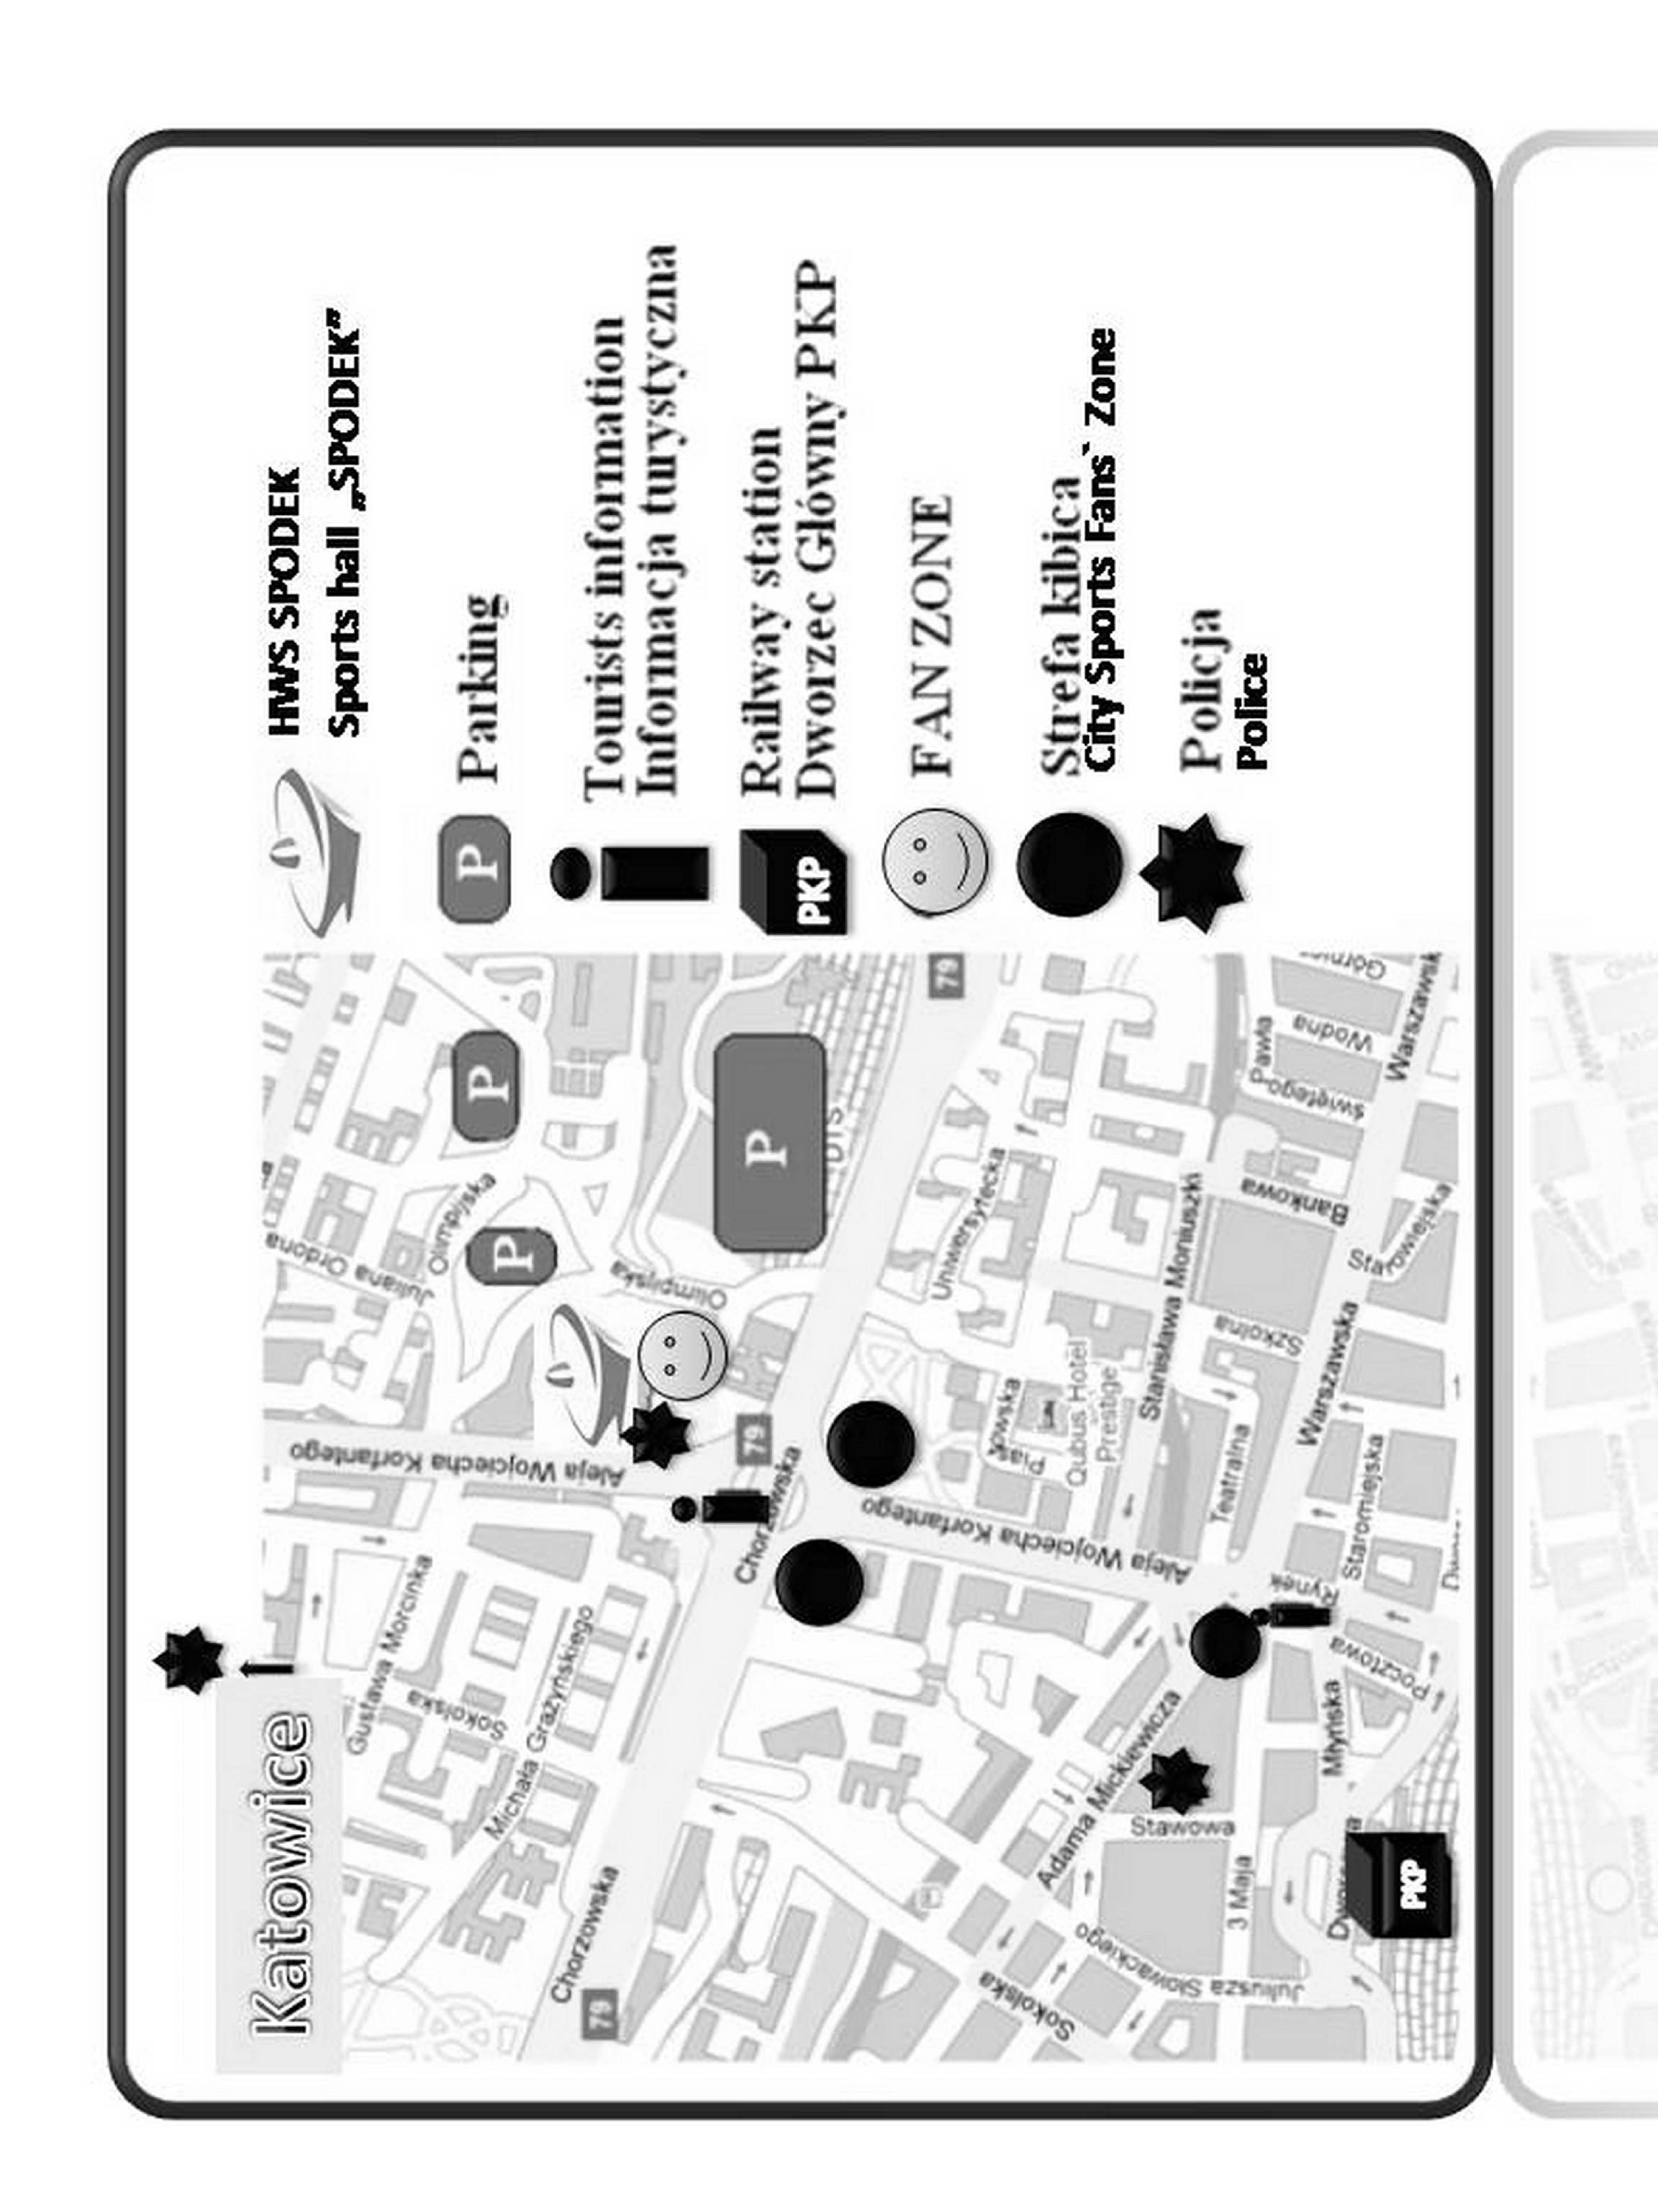
Opracowano w Wydziale Prewencji Komendy Miejskiej Policji w Katowicach

